TUM Open Infra Platform

End User Documentation - Short

Content

1. Overview 1

2. IFC Alignment 1.1 Support 1

3. System requirements 3

4. Starting the application 3

5. Basic Usage 4

6. Import 4

7. Export 4

8. Vertical Alignment 5

9. Source Code 6

10. Bug reports & Support 6

# Overview

The TUM Open Infra Platform (short OIP) supports several file formats for alignment and digital elevation data. It has export and import functions for IFC Alignment 1.0, IFC Alignment 1.1, LandXML 1.2 and OKSTRA 2.017.

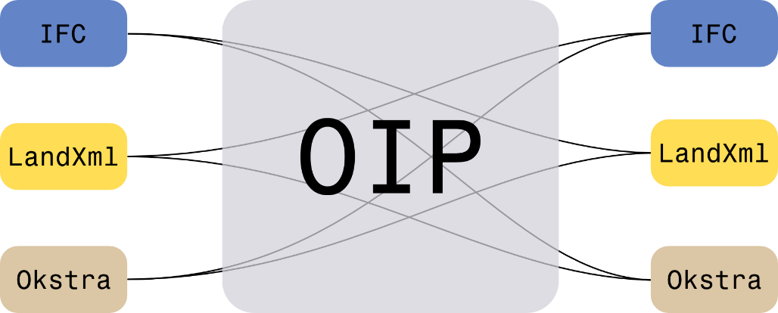

# IFC Alignment 1.1 Support

OIP supports IFC Alignment 1.1 partially. The following table gives a small overview of the support level of the different most important entity elements.

|  |  |
| --- | --- |
| Entity | Support Level (good), (basic), (minor) |
| IfcAlignment | good |
| IfcAlignment2DHorizontal | good |
| IfcAlignment2DHorizontalSegment | good |
| IfcAlignment2DVertical | good |
| IfcAlignmentCurve | good |
| IfcAxis2Placement3D | basic |
| IfcBuildingElementProxy | minor |
| IfcCircularArcSegment2D | good |
| IfcClothoidalArcSegment2D (deprected) | good |
| IfcCurveSegment2D | good |
| IfcDistanceExpression | minor |
| IfcGeographicElement | good |
| IfcGeometricRepresentationContext | basic |
| IfcGeometricRepresentationSubContext | basic |
| IfcLinearPlacement | minor |
| IfcMapConversion | basic |
| IfcOrientationExpression | minor |
| IfcProjectedCRS | basic |
| IfcTransitionCurveSegment2D | basic (only clothoids supported, other transition curve types are still work in progress) |
| IfcTriangulatedFaceSet | good |

OIP allows you to view the following example files:

|  |  |
| --- | --- |
| E.15.1 Vertical Alignment | http://www.buildingsmart-tech.org/ifc/review/IFC4x1/rc3/html/figures/examples/ex-vertical-alignment.png |
| E.15.2 Horizontal Alignment  IfcTransitionCurveSegment2D | http://www.buildingsmart-tech.org/ifc/review/IFC4x1/rc3/html/figures/examples/ex-horizontal-alignment.png |
| E.15.3 Terrain Surface  IfcTransitionCurveSegment2D | http://www.buildingsmart-tech.org/ifc/review/IFC4x1/rc3/html/figures/examples/ex-terrain-surface.png |
| E.15.4 Terrain and Alignment  IfcTransitionCurveSegment2D | http://www.buildingsmart-tech.org/ifc/review/IFC4x1/rc3/html/figures/examples/ex-terrain-alignment.png |
| E.15.6 Linear Placement  IfcDistanceExpression  IfcOrientationExpression  Check <https://youtu.be/PHix59ctie0> to find out how the IfcDistanceExpression can be modified manually to see the effects of changing it. | C:\Users\admin\AppData\Local\Microsoft\Windows\INetCache\Content.Word\TrafficSign.png |

# System requirements

The minimum requirements for TUM Open Infra Platform are:

* Windows 10
* 1-GHz-CPU
* 1 GiB RAM
* Screen resolution of at least 800 x 600 pixels
* DirectX12 compatible graphics card (at least feature level 11.0)
* Graphics card with 1.0 GiB of memory, for instance

Note: Only 64-bit editions of Windows are supported.

# Starting the application

After downloading the TUM Open Infra Platform ZIP-file, you need to extract it to a folder. The extracted folder will look like this:

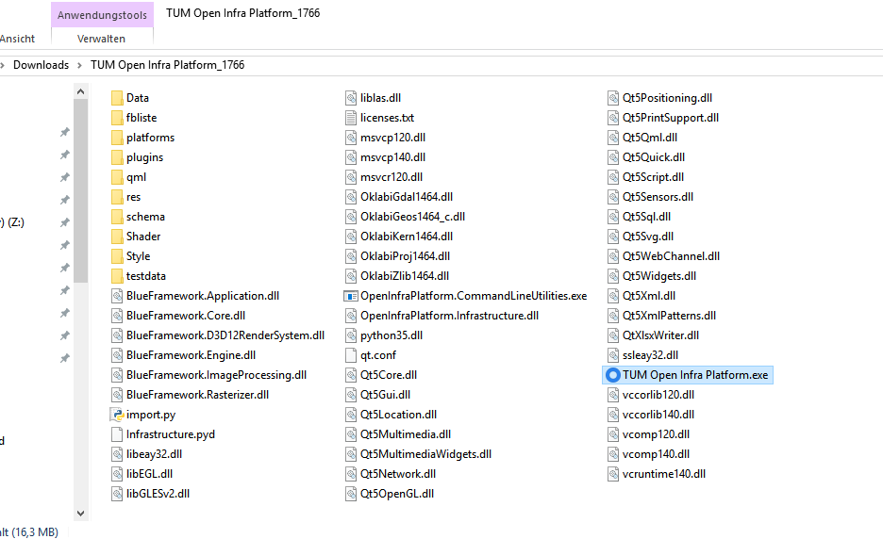

Double click on “TUM Open Infra Platform.exe” and the application will start.

# Basic Usage

#### Camera control

**Alt + Left Mouse Button + Move:** Rotate camera

**Right Mouse Button + Move:** Pan camera

**Mouse Wheel:** Zoom camera

#### More Details

Menu "Help" -> "Show Help..."

# Import

You can import an IFC 4.1/IFC Alignment 1.1 by clicking “File” -> “Open…”

A file in IFC Alignment 1.0 format can be imported by clicking “File” -> “Import” -> “Import IFC Alignment 1.0”

# Export

A file can be exported in IFC 4.1/IFC Alignment 1.1 file by clicking the menu item “File” -> “Exprot…” -> “IFC 4.1/IFC Alignment 1.1 (.ifc). See the following screenshot:

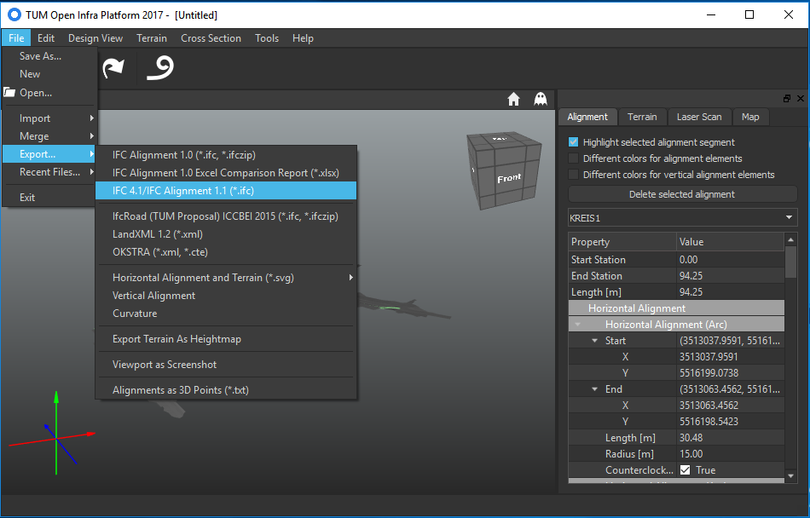

# Vertical Alignment

The vertical alignment can be viewed by selecting “Design View” -> “Vertical Alignment”. You can zoom by using the Mouse Wheel. If you hold the Ctrl-Key down while spinning the mouse wheel, only the Y-Axis of the vertical alignment is scaled.

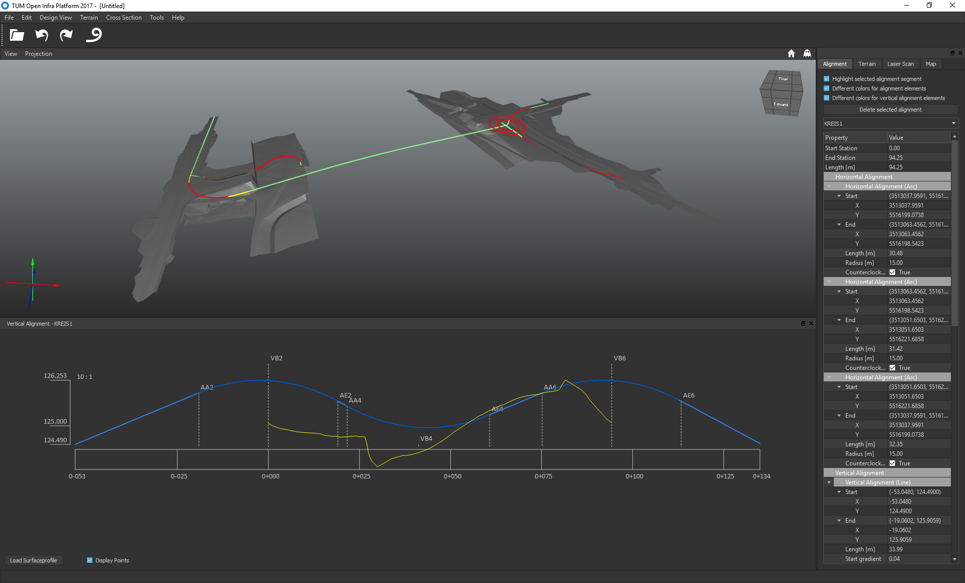

Figure 1: Screenshot of TUM Open Infra Platform

# Source Code

The source code of the TUM Open Infra Platform is hosted on [Bitbucket](https://bitbucket.org/tumcms)

The Open Infra Platform consist of three repositories:

[oipExpress](https://bitbucket.org/tumcms/oipexpress): Early binding generator for EXPRESS to support file loading and writing of IFC files

[BlueFramework3](https://bitbucket.org/tumcms/blueframework3-public): Simple 3D engine used for visualization

[Infrastructure Framework + UI](https://bitbucket.org/tumcms/openinfraplatform-public): Backend for managing different BIM data formats and a graphical frontend

The code is available under the GPL v3 license. If you need a different license, please contact us.

# Bug reports & Support

Please send your bug reports or support requests to [julian.amann@tum.de](mailto:julian.amann@tum.de). Include also the 'log.txt' (log file generated by application) in your attachment.